Dr MOHD MUDASSIR HUSSAIN  Professor & Principal  M.Pharm, Ph.D | 
Mr ASIMUDDIN AHMED  Assistant Professor  M.Pharm | 
Dr HASNAT FATIMA  Assistant Professor  Pharm D | 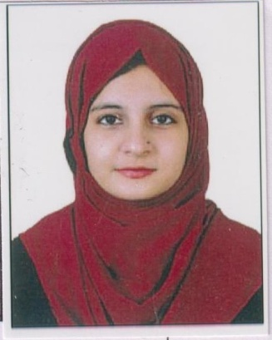
Miss SHAHISTA BEGUM  Assistant Professor  M.Pharm | 
Dr GOVULA AMARNATH  Professor  M.Pharm, Ph.D | 
Mr KRISHNA RAO PATNANA  Associate Professor  M.Pharm | 
Mrs FIRASATH FATIMA  Assistant Professor  M.Pharm | 
Miss AMREEN BEGUM  Assistant Professor  M.Pharm | 
Miss AMINA FATIMA  Assistant Professor  M.Pharm | 
Miss AYESHA JABEEN  Assistant Professor  M.Pharm | 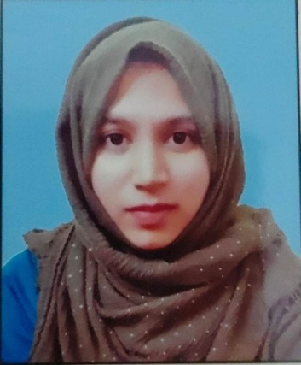
Mrs AFREEN ANJUM  Assistant Professor  M.Pharm | 
Mr ABDUL MUTALIB  Assistant Professor  M.Pharm | 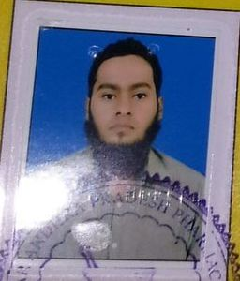
Mr VEERABOMMA RAJESH  Associate Professor  M.Pharm | 
Mrs SYED UZRA ANJUM  Associate Professor  M.Pharm | 
Mr SYED HASSAN RAZACK  Associate Professor  M.Pharm | 

